**Ideation Report Template**

# Professional Resume : Software Developer

## 1. Introduction

* This high-quality personal website will serve as both portfolio and resume of a software developer that **strikes the perfect balance** between creative and professional.
* First of all, it’s super user-friendly. It will tell end-user’s personal story with interesting graphics and icons, using a **perfect color scheme**. Navigation through Profile,

Experiences, Abilities, Projects, Work experience, Skills, Contact and About me pages is perfectly smooth and it’s an incredible thing to do, as it will give accurate info about enduser’s work. Also it also helps in digital marketing and promotions of the end-user’s work.

### 2. User Interface Design and Prototype

* The site will most likely include the following features : Profile, Experiences, Abilities, Projects, Work experience, Skills, Contact and About me pages.
* By having these features visitors of website can get to know about end-user’s work, skills, experiences , contact information etc. about the end-user.

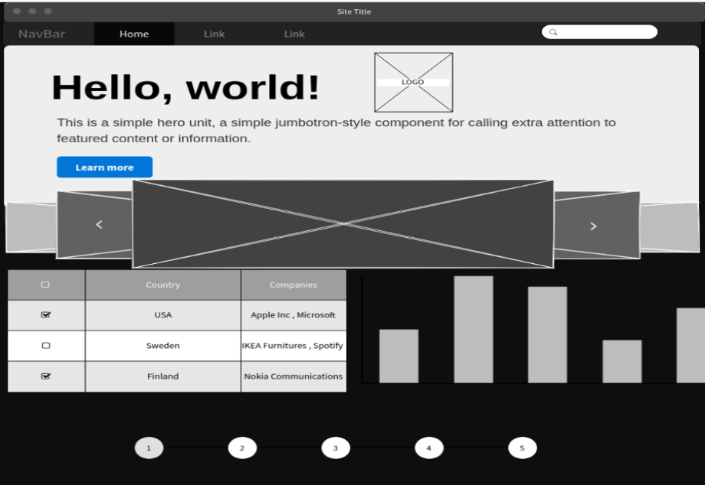

### 3.Navigation Structure

* It is not the exact idea behind my website , but it’s the somewhat graphical presentation of it , which can be changed too. And which includes way more features, but somewhere design can be similar to this.

## 4. References

• All the reference webites are given below :

* + <https://www.rachelebsmith.com/> - Brooke Smith(Fitness Trainer)
  + <https://andrevv.com/> -Andrew MacCarthy(Designer)
  + <https://gruev.space/> -Vladimir Gruev(UI/UX Designer)
  + <https://www.justinbiebermusic.com/> -Justin Bieber(Singer)
  + <http://www.jackiechan.com/> -Jackie Chan(Actor)